Ideation phase

Brainstorming & Prioritization Template
Date | 06 November 2025
Team ID | F529277D47452DB9E7447BD087E08E5E
Project Name | Medical inventory management
Maximum Marks | 4 Marks

1. Problem Statement
Clearly describe the issue being addressed.
Example:
Hospitals face major challenges in tracking medical supplies, monitoring stock levels, and managing expiration dates. This leads to medicine wastage, supply shortages, and inefficient inventory control.

2. Brainstorming Setup
- Encourage open and creative thinking — no idea is too small or unrealistic.
- Focus on generating as many ideas as possible before evaluating them.
- Involve diverse roles such as doctors, nurses, pharmacists, IT staff, and administrators.
- Set a time limit for brainstorming (e.g., 15–20 minutes).
- Develop a mobile app that allows nurses to check stock availability in real time.
- Implement AI tools to predict medicine demand based on usage patterns.
- Introduce RFID tags for real-time tracking of inventory and equipment
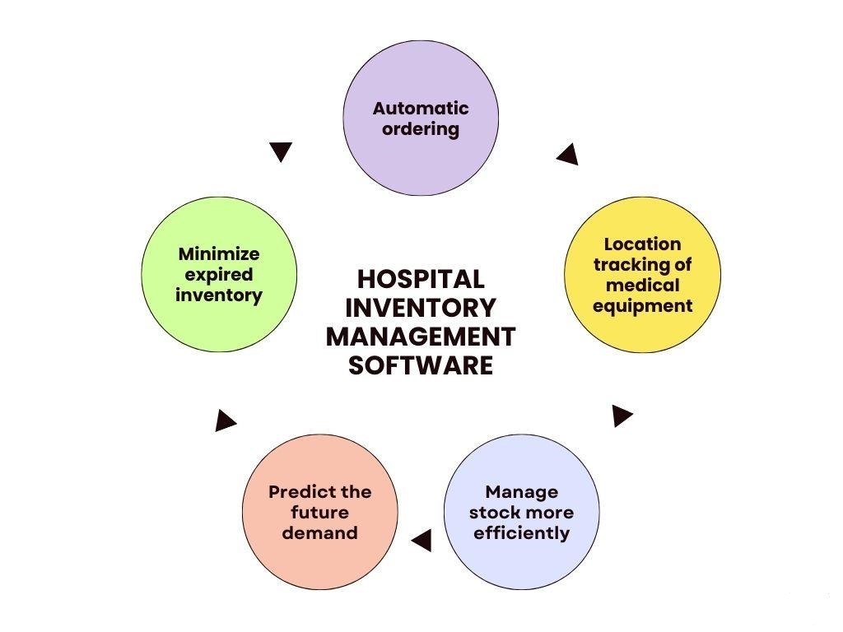

3. Idea Generation
- Use barcode scanners for tracking all medicine transactions.
- Create automatic alerts for low stock and upcoming expirations.
- Integrate supplier systems for automatic reordering when stock is low.
- Develop a mobile app that allows nurses to check stock availability in real time.
- Implement AI tools to predict medicine demand based on usage patterns.
- Introduce RFID tags for real-time tracking of inventory and equipment.

4. Idea Evaluation
Each idea can be rated based on two main factors:
- Feasibility: How easy and cost-effective it is to implement (scale 1–5).
- Impact: How strongly it improves efficiency, reduces errors, or saves cost (scale 1–5).

5. Prioritization
- High Priority:
Barcode scanning, expiry alerts, and the nurse mobile app — all are feasible and offer immediate benefits.
- Medium Priority:
Supplier API integration and AI-based demand prediction — slightly complex but valuable long-term.
- Low Priority:
RFID tracking — high accuracy but costly and complex to implement.

6. Action Plan
- Develop a prototype for stock tracking dashboard (Owner: IT Team, Deadline: Dec 15).
- Implement the expiry alert system (Owner: Pharmacy Department, Deadline: Dec 20).
- Research cost and vendors for RFID tracking (Owner: Procurement Team, Deadline: Jan 5).

